Fix for “Event Filters” not displaying

If you can’t see the “Event Filter” buttons in the video room when managing videos as shown in Screen Shot 1 below, then it is likely that the text size you are using to view the webpage is too large and this is easy to fix.
Screen Shot 1 (“Event Filters” not displayed)
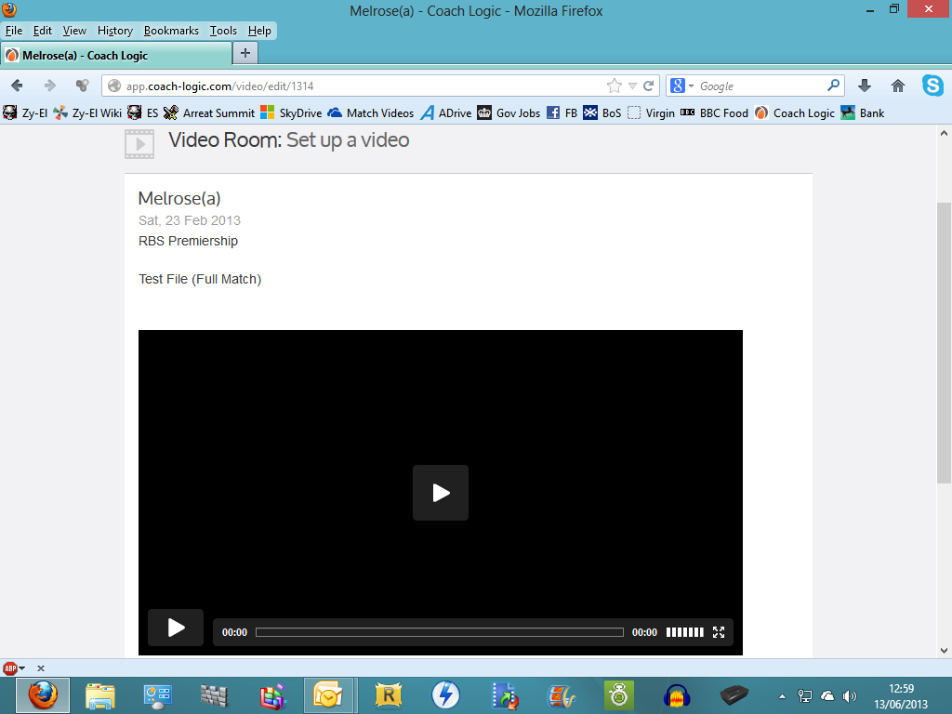
To fix this, simply go to the “View” menu in whichever browser you are using and click-on “Zoom Out” as shown in Screen Shot 2 on Page 2 below.
Screen Shot 2 (Zoom Out)
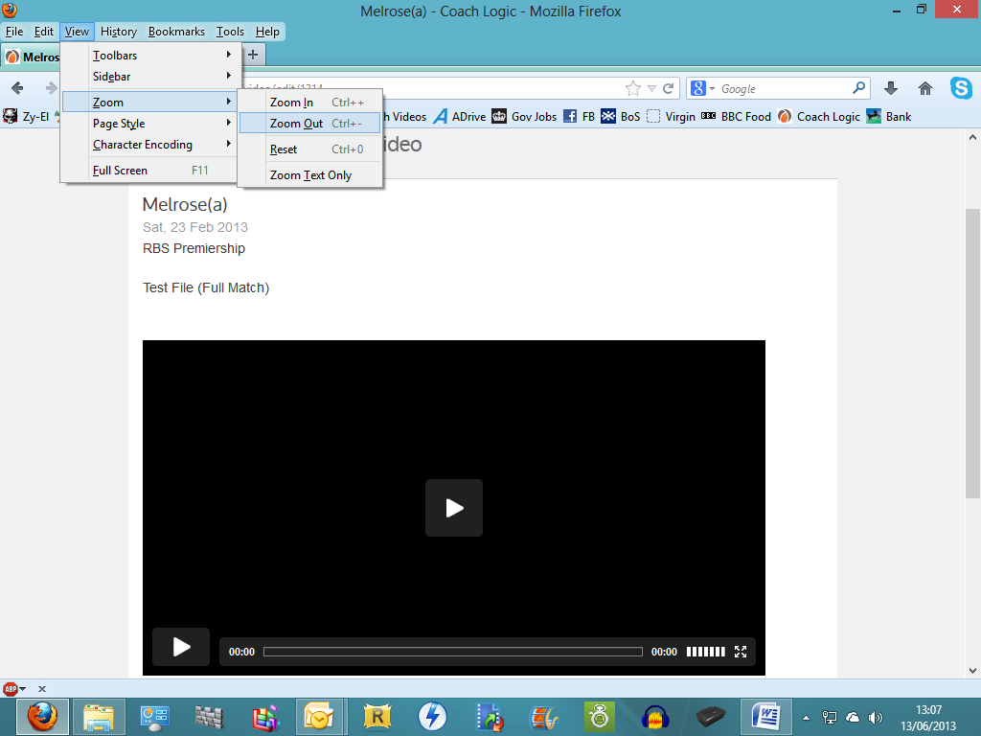
This will reduce the size of the text on screen and should now display the “Event Filters” as is shown in Screen Shot 3 on Page 3 below.

Screen Shot 3 (“Event Filters” displaying)
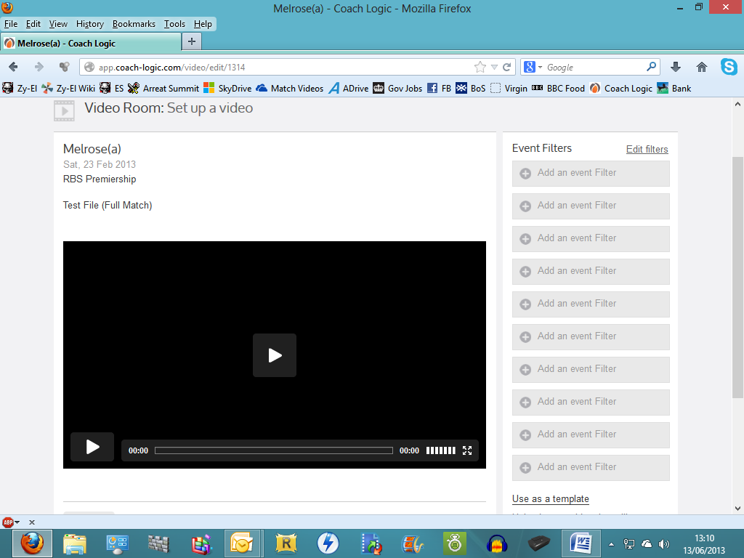
This should work in any browser and on any platform. My example used Windows 8.

